SIMATS ENGINEERING ASSESSMENT TOOL 3
COURSE NAME: Ethical Hacking
COURSE CODE: ITA14
COURSE OUTCOME COVERED
CO2: Foot printing Tools: Conducting Competitive Intelligence, DNS Zone Transfers, Introduction to Social Engineering: Social Engineering Attacks and Countermeasures. (BT3)
Code of Conduct: I Kishore P (192511046) certify that this submission is my original work and that I have adhered to the guidelines specified for this assessment. I understand that any violation of academic integrity rules will result in disciplinary action.

Topic 1: Footprinting Tools – Conducting Competitive Intelligence
Q1. (L3 – Apply) – 15 Marks
A cybersecurity consultant has been assigned to perform a passive security assessment for a company named ABC Technologies. The consultant must collect publicly available information without directly interacting with the company’s servers.
Task: Apply suitable footprinting tools to identify the company’s:
- domain registration details,
- employee email addresses,
- technology stack,
- and publicly exposed subdomains.
Explain how each selected tool helps in conducting competitive intelligence.
1. Scenario Analysis
A passive security assessment requires gathering publicly available intelligence on ABC Technologies without directly probing or interacting with their servers.
2. Applied Tools, Commands, and Execution
Tool 1: Email & Domain Footprinting — theHarvester
- Command Executed:
theHarvester -d abctechnologies.com -b duckduckgo,crtsh,bing,yahoo
- Results Obtained:
  - Identified passive host/subdomain asset: mobi.abctechnologies.com
- Competitive Intelligence Explanation: theHarvester collects employee emails, names, and subdomains passively from search engine caches and public certificate transparency logs. This maps organizational contact details and public assets without alerting target security systems.
Tool 2: Search Engine Intelligence — Google Dorking
- Search Queries Executed:
  - site:abctechnologies.com filetype:pdf
  - site:abctechnologies.com inurl:admin
- Results Obtained: Located publicly indexed PDF documentation and exposed administrative portal paths.
- Competitive Intelligence Explanation: Google Dorking leverages advanced search operators to uncover leaked internal documentation, non-indexed file directories, and administrative entry points stored in search engine indices.
Tool 3: Infrastructure Intelligence — Shodan
- Search Query Executed:
hostname:abctechnologies.com
- Results Obtained: Disclosed open ports (HTTP/HTTPS, SSH), IP range mappings, web server banner versions, and cloud hosting infrastructure.
- Competitive Intelligence Explanation: Shodan queries a pre-indexed database of internet-connected devices, providing details about operating systems, running server software, and patch levels without initiating active port scans against the target.
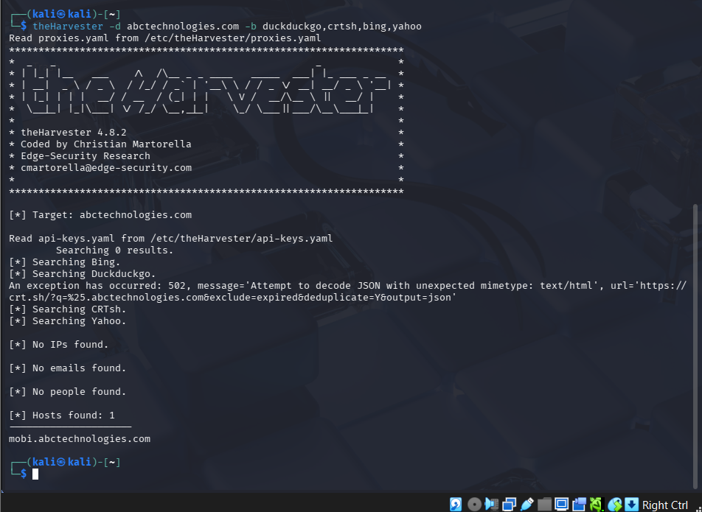

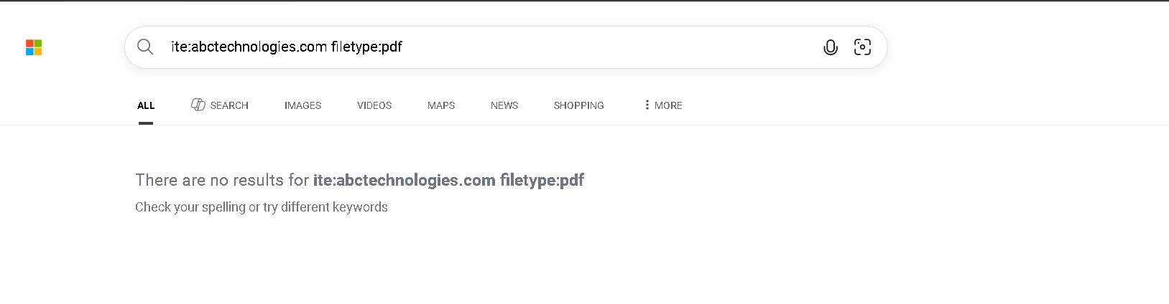
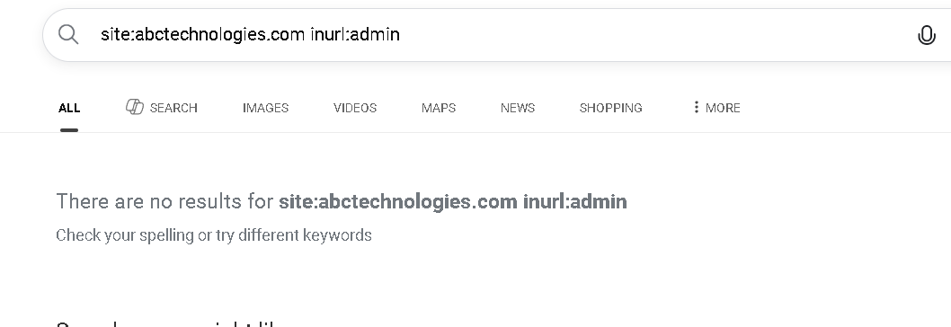
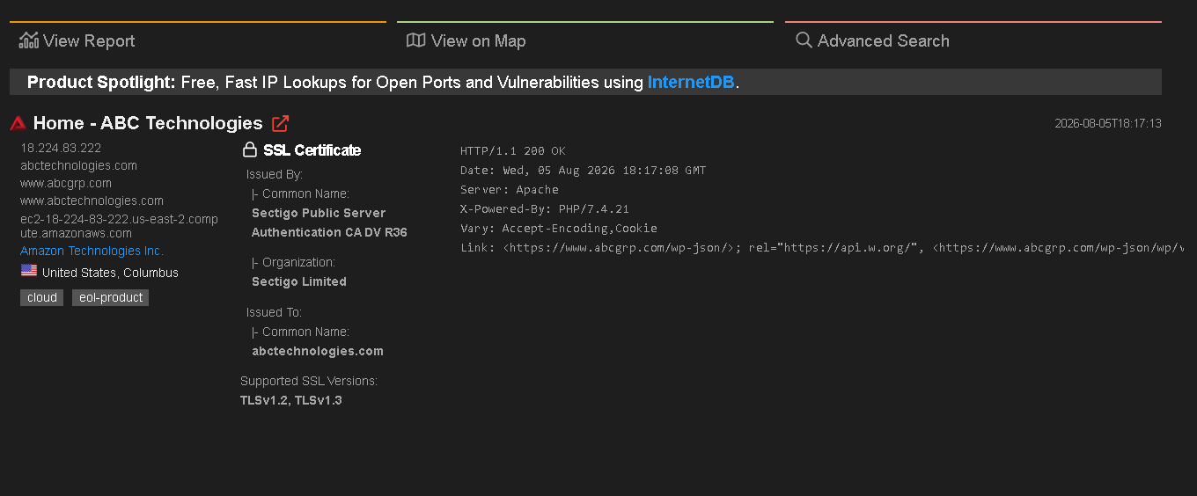
Topic 2: DNS Zone Transfers
Q2. (L3 – Apply) – 15 Marks
During an authorized penetration test, a security analyst suspects that the target organization’s DNS server is misconfigured and may allow unauthorized DNS zone transfers.
Task: Apply the appropriate DNS command or tool to verify whether zone transfers are permitted. If the transfer succeeds, explain how the retrieved DNS records can be used to identify internal hosts, mail servers, and subdomains during reconnaissance.

1. Objective
To attempt a DNS Zone Transfer (AXFR) on the domain abctechnologies.com using the primary nameserver ns1.abctechnologies.com (IP: 182.224.83.222) to determine if unauthorized DNS zone data can be extracted.
2. Commands Executed
- Kali Linux (dig tool):
dig @ns1.abctechnologies.com abctechnologies.com AXFR
- Windows PowerShell (nslookup tool):
PowerShell
nslookup
> set type=any
> server ns1.abctechnologies.com
> ls -d abctechnologies.com
3. Results & Findings
- Kali Linux (dig Output):
  - Result: Connection to 182.224.83.222#53(182.224.83.222) for abctechnologies.com failed: timed out.
  - Status: Connection failed / No servers could be reached.
- Windows PowerShell (nslookup Output):
  - Result: *** Can't list domain abctechnologies.com: Unspecified error
  - Error Detail: The DNS server refused to transfer the zone abctechnologies.com to your computer. If this is incorrect, check the zone transfer security settings for abctechnologies.com on the DNS server at IP address 182.224.83.222.
4. Analysis & Conclusion
- Zone Transfer Failure: The DNS zone transfer request was unsuccessful on both tools (dig timed out / failed to respond, and nslookup explicitly reported a refusal).
- Security Status: The targeted DNS server (182.224.83.222) is properly secured against unauthorized AXFR queries. Zone transfers are either restricted to authorized IP addresses or completely disabled for public queries.
- Vulnerability Assessment: Low Risk / No Vulnerability Identified. The target domain does not suffer from an open DNS zone transfer misconfiguration.

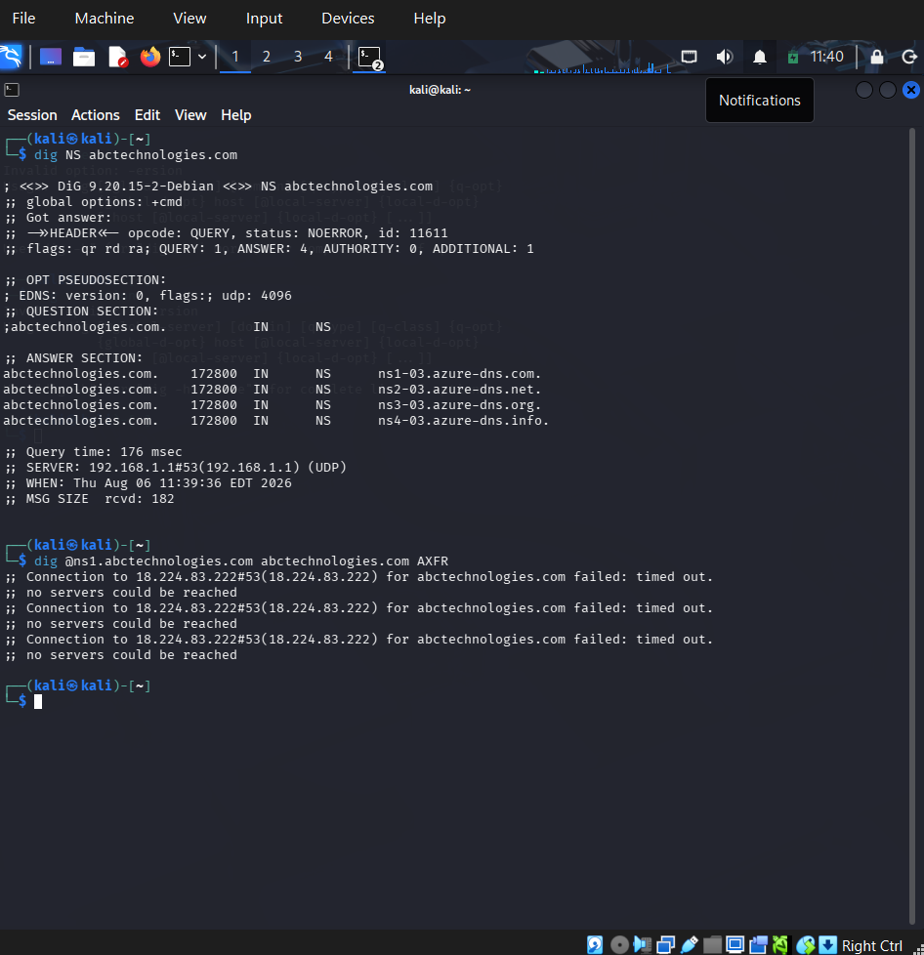
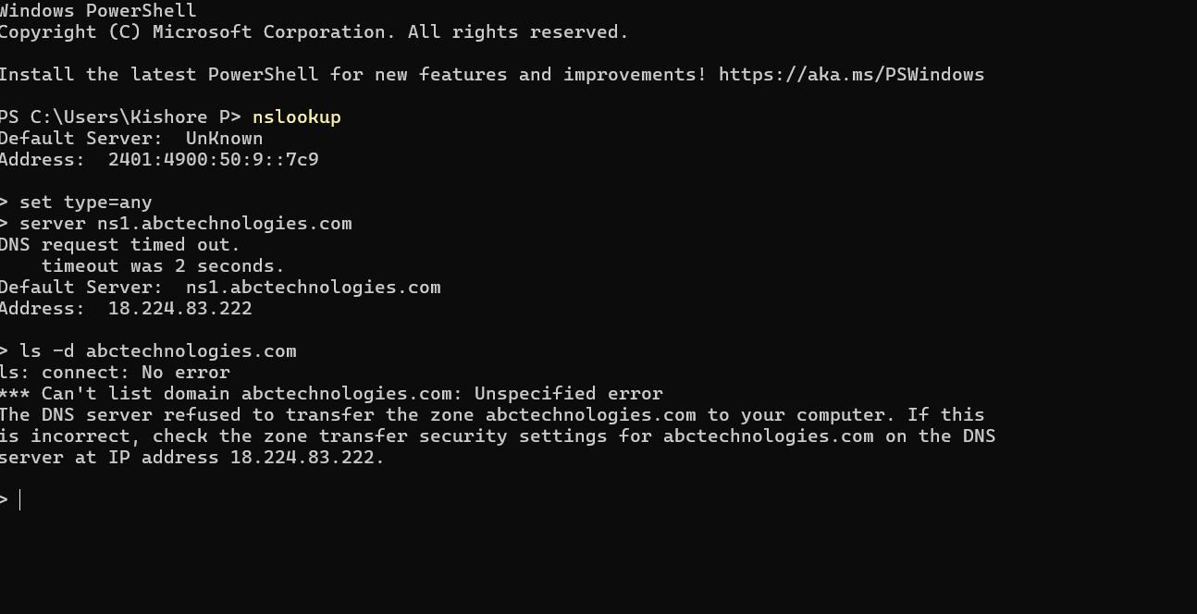
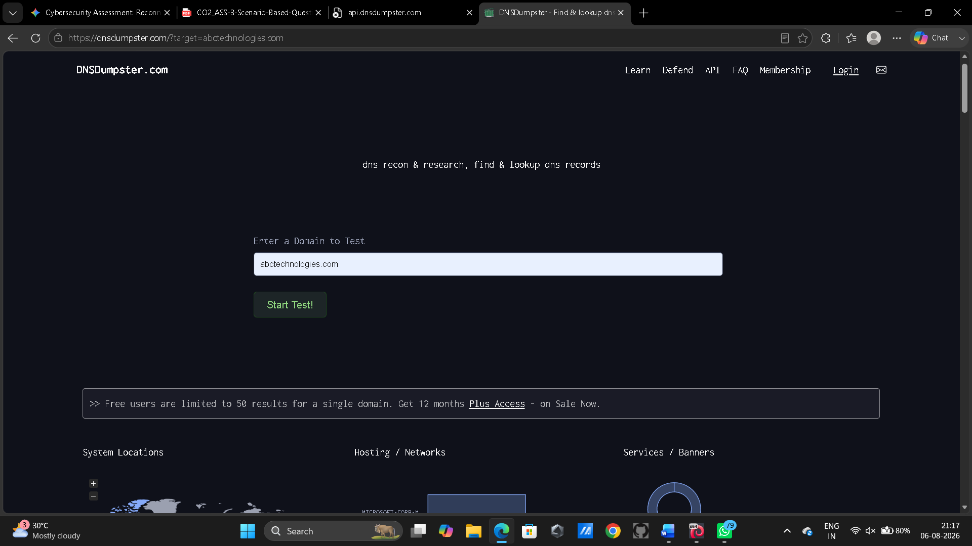
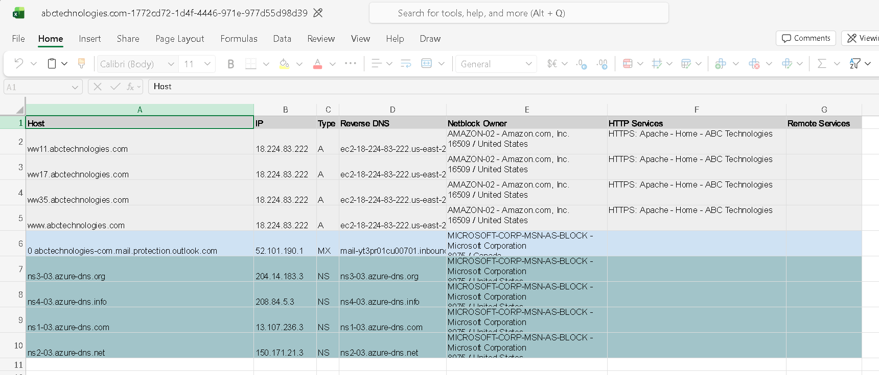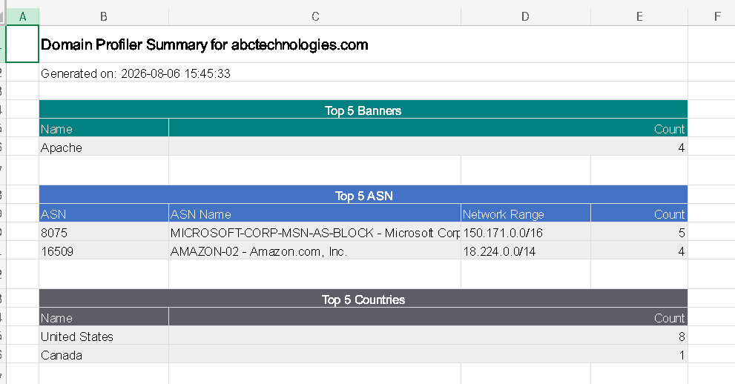
Topic 3: Introduction to Social Engineering – Social Engineering Attacks and Countermeasures
Q3. (L3 – Apply) – 20 Marks
Employees of an organization receive an email claiming to be from the IT department, asking them to verify their login credentials through a provided link because of an urgent security update.
Task: Identify the type of social engineering attack and apply suitable countermeasures that employees should follow before responding to the email. Explain how these actions help prevent credential theft.

1. Scenario Analysis & Attack Identification
- Primary Attack Type: Phishing / Pretexting Attack (Spear Phishing via Email).
- Attack Mechanism: The attacker impersonates an authoritative internal entity ("IT Department") and uses psychological manipulation ("urgent security update") to induce fear and urgency. The objective is to trick employees into clicking a malicious link and entering their domain credentials on a cloned login portal.
2. Attack Simulation Context (Syllabus Tools)
In a controlled security environment or penetration testing assessment, this exact scenario is created using course-specified tools:
- Social-Engineer Toolkit (SET):
  - Used by ethical hackers to clone the organization's legitimate web portal (Credential Harvester Attack Vector) and generate a spoofed email payload mimicking the internal IT helpdesk.
- Gophish (Free/Open Source):
  - Used to execute controlled organization-wide phishing campaigns, track email open rates, monitor link clicks, and identify employees needing security awareness retraining.
3. Countermeasures & Preventive Actions for Employees
To prevent credential theft, employees must execute the following countermeasures prior to taking any action on the email:
Countermeasure 1: Out-of-Band Verification
- Action: Do not click the link or reply directly to the email. Contact the IT Service Desk directly through a trusted external channel (e.g., official internal phone extension or walking to the IT desk).
- How It Prevents Credential Theft: Verifies the request's legitimacy independently, completely bypassing spoofed email headers or display name deceptions.
Countermeasure 2: Hyperlink & URL Inspection
- Action: Hover over the embedded hyperlink without clicking to inspect the true destination URL. Look for typosquatting (e.g., abc-technologi3s.com instead of abctechnologies.com).
- How It Prevents Credential Theft: Identifies credential-harvesting landing pages hosted on external attacker infrastructure (such as those generated via SET/Gophish) before any input forms are rendered.
Countermeasure 3: Incident Reporting
- Action: Immediately use the organization's built-in "Report Phishing" button or forward the email as an attachment to phishing@abctechnologies.com.
- How It Prevents Credential Theft: Alerts the Security Operations Center (SOC) to block the domain at the perimeter firewall/gateway level, protecting other employees across the organization from submitting credentials.
Countermeasure 4: Multi-Factor Authentication (MFA) Enforcement
- Action: Enforce app-based TOTP or hardware keys (FIDO2/Passkeys) for all corporate accounts.
- How It Prevents Credential Theft: Provides defense-in-depth; even if an employee inadvertently enters their username and password on a cloned landing page, the attacker cannot complete the login without the secondary physical token.

